Worksheet 3.1

Student Name: Sahil Kaundal UID: 21BCS8197

Branch: CSE (Lateral Entry) Section/Group:20BCS-807_B Semester: 4th Date of Performance: 25/04/2022

Subject Name: SE Lab Subject Code: 20CSP-255

Q1.

1. Aim/Overview of the practical:

Design a Gantt chart for a food delivery application.

1. Task to be done/ Objective:



Design a Gantt chart for a food delivery application.

1. Requirement Analysis:

Software Requirement:

* Smart Draw
* Google Chrome
* Excel

Hardware Requirement:

* Computer
* Windows 10
* Power Supply

1. Gantt Chart:

A Gantt chart, commonly used in project management, is one of the most popular and useful ways of showing activities (tasks or events) displayed against time. On the left of the chart is a list of the activities and along the top is a suitable time scale. Each activity is represented by a bar; the position and length of the bar reflects the start date, duration and end date of the activity. This allows you to see at a glance:

* What the various activities are
* When each activity begins and ends
* How long each activity is scheduled to last
* Where activities overlap with other activities, and by how much
* The start and end date of the whole project

Gantt chart for a food delivery application.

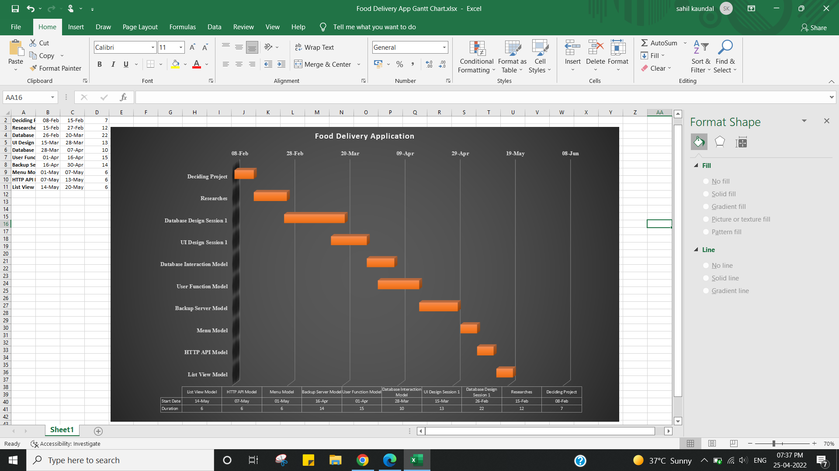

Q2.

1. Aim/Overview of the practical:

Design a Gantt chart for a gaming application.

1. Task to be done/ Objective:



Design a Gantt chart for a gaming application.

1. Requirement Analysis:

Software Requirement:

* Smart Draw
* Google Chrome
* Excel

Hardware Requirement:

* Computer
* Windows 10
* Power Supply

1. Gantt Chart:

A Gantt chart, commonly used in project management, is one of the most popular and useful ways of showing activities (tasks or events) displayed against time. On the left of the chart is a list of the activities and along the top is a suitable time scale. Each activity is represented by a bar; the position and length of the bar reflects the start date, duration and end date of the activity. This allows you to see at a glance:

* What the various activities are
* When each activity begins and ends
* How long each activity is scheduled to last
* Where activities overlap with other activities, and by how much
* The start and end date of the whole project

**Gantt chart for a gaming application.**

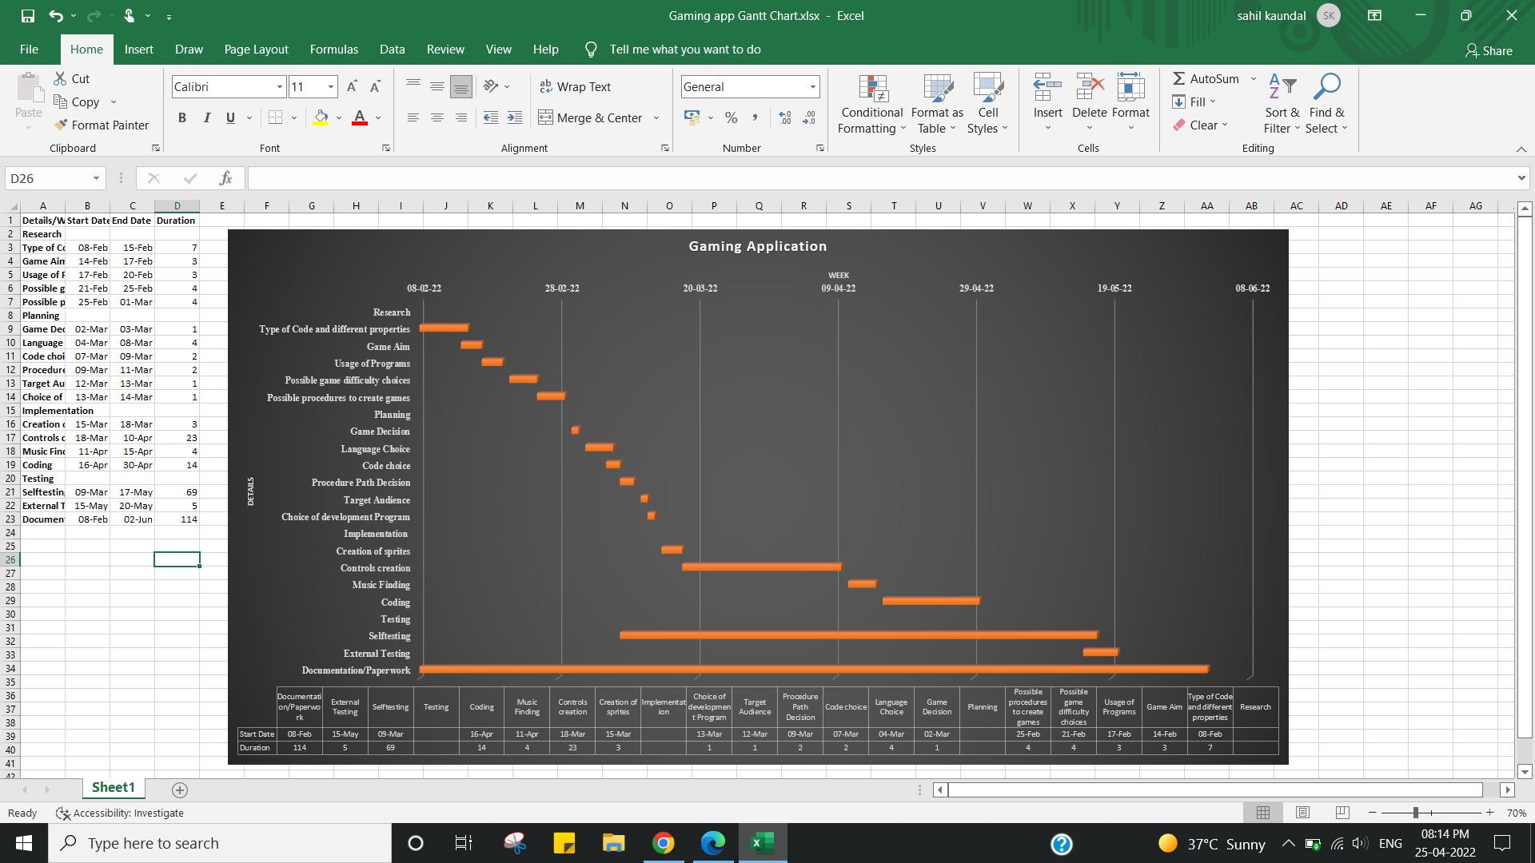

1. Result/Output/Writing Summary:

I have successfully done this practical.

Learning outcomes (What I have learnt):

1. Learned about Gantt Chart.
2. Learned about Gantt chart for a food delivery application.
3. Learned about Gantt chart for a gaming application.

Evaluation Grid (To be created as per the SOP and Assessment guidelines by the faculty):



|  |  |  |  |
| --- | --- | --- | --- |
| Sr. No. | Parameters | Marks Obtained | Maximum Marks |
| 1. |  |  |  |
| 2. |  |  |  |
| 3. |  |  |  |
|  |  |  |  |